RFID Hall Pass – Final Project

Christopher Yang, Lautaro Stamati

Week 1 – 4/18/2025

Executive Summary:

- It turns out that online simulation softwares did not support coding capabilities.

- We started physically constructing our circuit, and we swapped out the NRF24L01 for a ESP32 Wifi Module. Code was also developed, so right now the team has figured out how to read RFID UIDs.

- Waiting for NRF24L01’s to arrive and also waiting for more modules to be built, in order to test out the wireless communication capabilities.

Schematic:

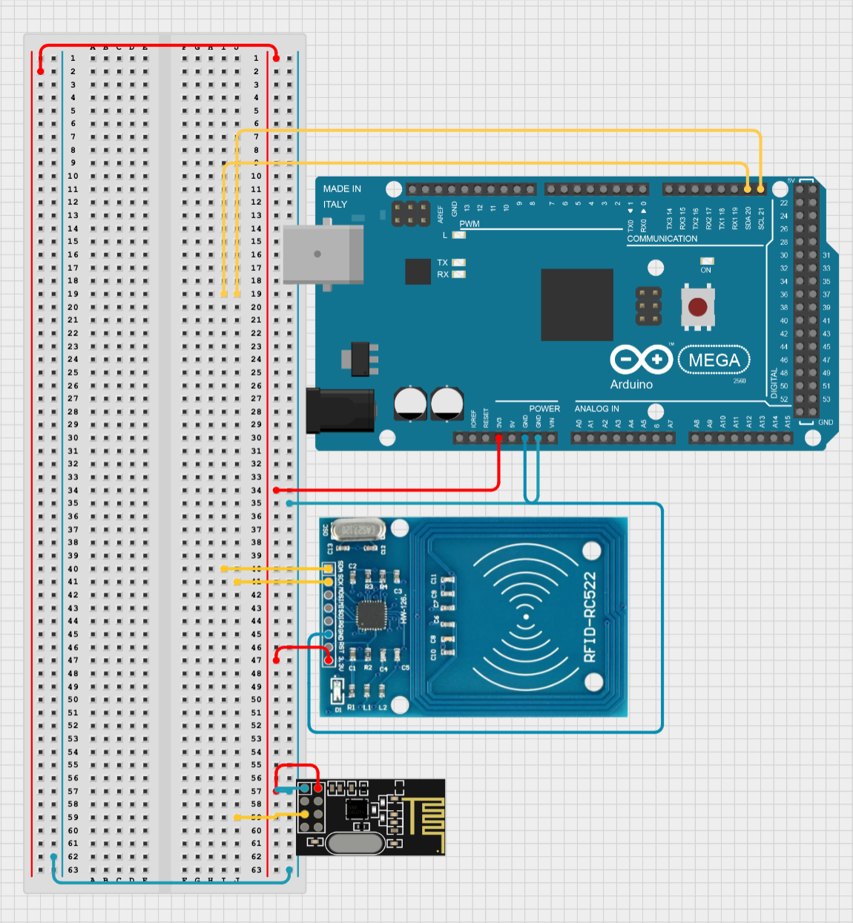

Gantt Chart & Planning:

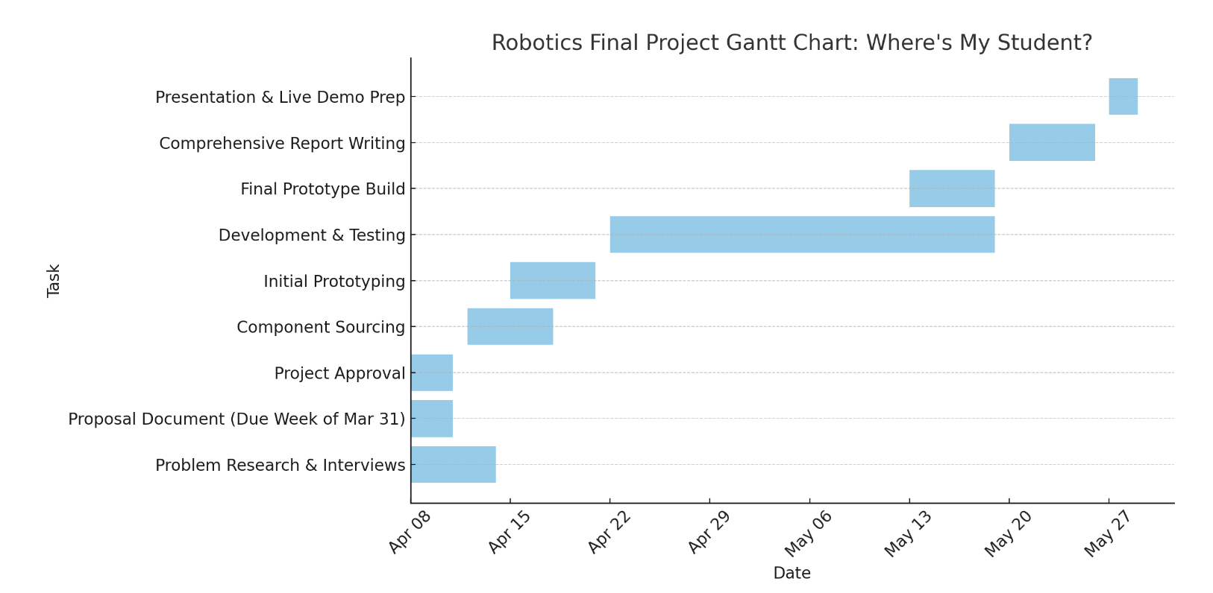

- Next week, the team’s goal is to be able to write or have some sort of structural organization of RFID tags, to move closer towards the goal of recording detection instances.